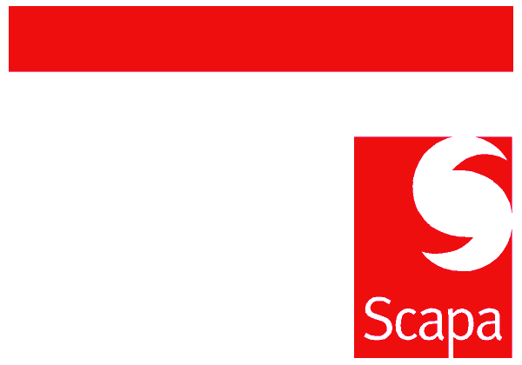
MEMORANDUM

To:  Subject: | All Employees  Launch of All Staff Employee Survey | From:  Date: | Calvin O’Connor  14th August 2009

Dear Colleague

I am today delighted to launch the ‘My Views’ employee survey which we are running to gather information about how you feel about working at Scapa and how well your training, development and career needs are being met.
The survey, which will remain open for 2 weeks, is being managed by an external expert company called People Insight. All completed surveys will go to them so you can be assured that the survey is completely anonymous. Please do take this opportunity to take part and be as open and honest as possible so that we can get maximum benefit from this process.
We are providing the survey in multiple languages and in both hard copy and electronic format to make it as accessible as possible for all staff.
Hard copies of the survey have been despatched to all Site Managers who will be making arrangements to distribute these to you as quickly as possible. You will also receive with the survey a pre-addressed envelope which will enable you to return the survey directly to People Insight.
Anyone who is completing the English on-line version of the survey will receive an email directly from People Insight which will contain a link to a web site.
The closing date for the online survey is 27th August and the deadline for receipt of hard copies by post is 3rd September.
Once the results have been analysed, the feedback will be communicated and issues identified will be discussed and a plan of action agreed.
Instructions on how to complete the survey are clearly marked on the document but if you have any questions at all then please approach your line manager in the first instance.
Thank you in advance for your involvement and I do hope that as many of you as possible take this opportunity to let us have your views.
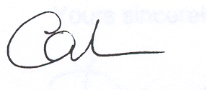

Calvin O'Connor

Chief Executive

